**CREATE A DATABASE IN CLOUDANT DB**

|  |  |
| --- | --- |
| TEAM ID | PNT2022TMID50747 |
| PROJECT | Smart Waste Management System For Metropolitan Cities |

**To create a data base in Cloudant DB**

**STEPS:**

* Logged in to IBM Cloud account.
* Navigated to `. /resources`.
* Clicked on the “Create Resource +” button.
* Searched for “Cloudant”.
* Chose the “Lite Version” and clicked on “Create”

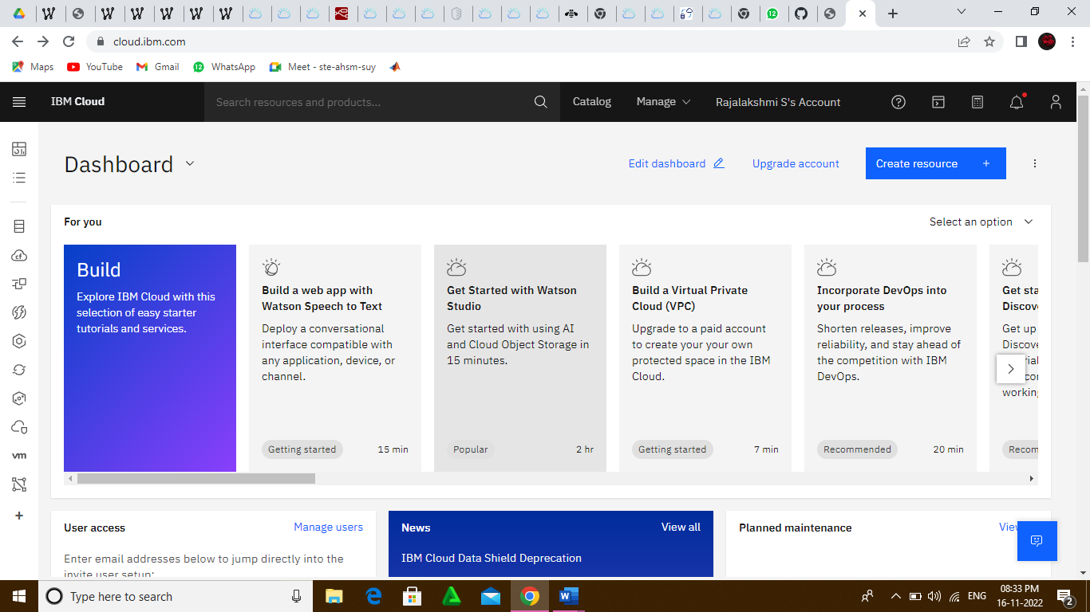

* The cloudant database resource was created successfully
* Clicked on launch dashboard

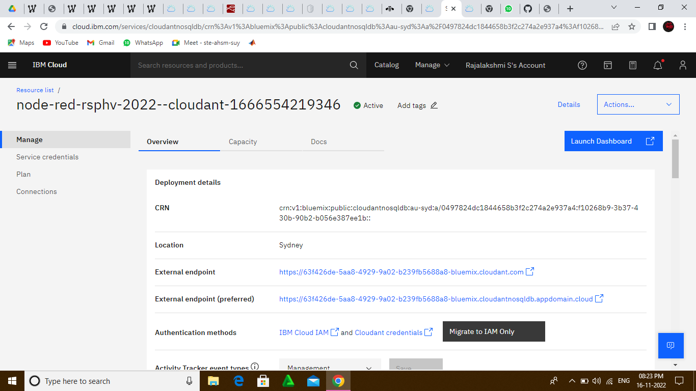

* Clicked on “Create Database” and entered “meowman” as the database name and the “Non-partioned” option

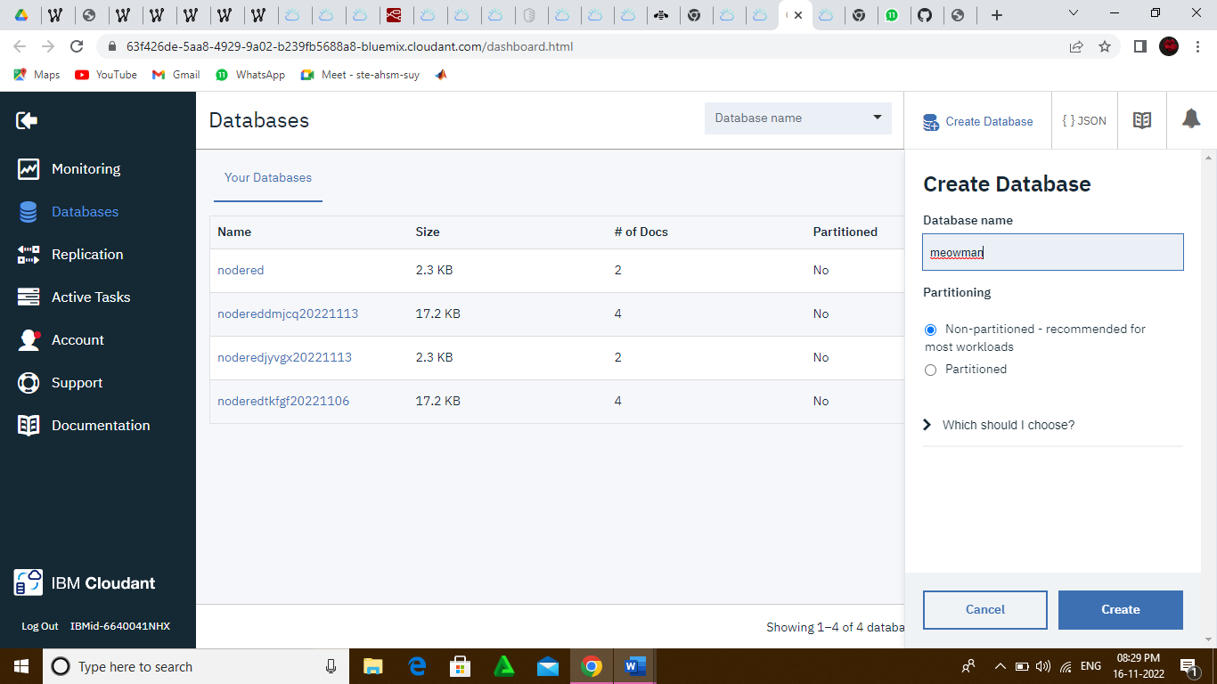

The database “meowman” created successfully

